MySql中报错：java.sql.SQLException: Incorrect string value: '\xF0\x9F\x90\xBB' for column
今天读取solr里面的数据，往mysql插入时报错， Incorrect string value: '\xF0\x9F\x93\x8D\xE8\x88...' for column 'title' at row 1
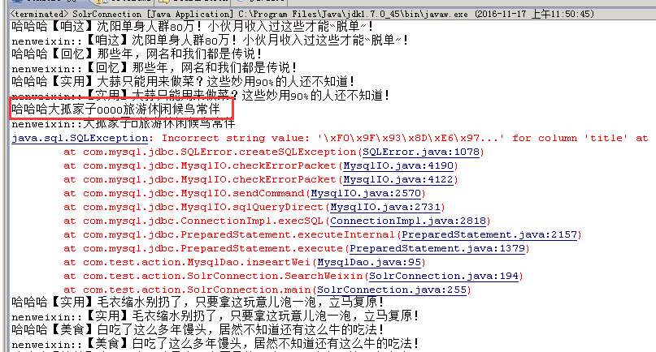
原因是标题有Emoj表情相关字符，该种字符串为Emoj表情内容，每个字符占用4个字节，在Mysql中默认最大支持3个字节，即utf8，超长了，所以报错了。需要修改为utf8mb4

解决方法：
1.建表的时候添加如下限制：ENGINE=InnoDB DEFAULT CHARSET=utf8mb4 COLLATE=utf8mb4_bin;
2.在my.cnf上修改如下：
------------------my.cnf------------------------------------------------------
# For advice on how to change settings please see
# http://dev.mysql.com/doc/refman/5.6/en/server-configuration-defaults.html
[client]
default-character-set=utf8mb4
[mysql]
default-character-set = utf8mb4
# Remove leading # and set to the amount of RAM for the most important data
# cache in MySQL. Start at 70% of total RAM for dedicated server, else 10%.
# innodb_buffer_pool_size = 128M

# Remove leading # to turn on a very important data integrity option: logging
# changes to the binary log between backups.
# log_bin
# These are commonly set, remove the # and set as required.
# basedir = .....
# datadir = .....
# port = .....
# server_id = .....
# socket = .....

# Remove leading # to set options mainly useful for reporting servers.
# The server defaults are faster for transactions and fast SELECTs.
# Adjust sizes as needed, experiment to find the optimal values.
# join_buffer_size = 128M
# sort_buffer_size = 2M
# read_rnd_buffer_size = 2M

sql_mode=NO_ENGINE_SUBSTITUTION,STRICT_TRANS_TABLES
log-error=/var/log/mysqld.log
long_query_time=3

[mysqld]
character-set-client-handshake = FALSE
character-set-server = utf8mb4
collation-server = utf8mb4_unicode_ci
init_connect='SET NAMES utf8mb4'

#log-slow-queries= /usr/local/mysql/log/slowquery.log
------------------------------------------------------------------------
重启mysql服务，service mysql stop； service mysql start；问题解决。
造成这个问题的原因（网上找的）：
mysql中规定utf8字符的最大字节数是3，但是某些unicode字符转成utf8编码之后有4个字节，导致出错。

同时，数据库的字符编码和表表中对应字段的字符编码也需要改变，如下：

对应数据库字符编码为：
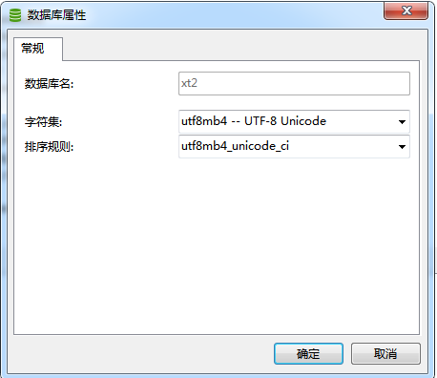

表字段编码：
